# Contents

Contents 1

1. Introduction 2

2. Literature Review and Designing 2

2.1. Background research 2

2.2. Core mechanism – jetpack 2

2.3. Core mechanism – HUD 4

2.4. Subsystems 6

3. Methodology 6

3.1. Tools and platforms 6

3.2. Basic play information 6

3.3. Game flow 7

3.4. Player hierarchy 7

3.5. HUD 8

3.6. Jetpack 10

3.7. Grappling Hook 11

3.8. Wrist menu 11

3.9. Tutorial 12

3.10. Level design 12

4. Evaluation 12

4.1. Self-analysis 12

4.2. User test designing 13

4.3. Survey questionnaire 14

4.4. Survey results and analysis 19

5. Conclusion 28

6. References 28

# Introduction

This research project is oriented to explore human-computer interaction (HCI) performances and gameplay of original game based on virtual reality (VR) platform. As the software section, one electronic game is designed and developed by the proposer with unique core mechanism, utilizing human-computer interaction feature specific to VR. Considering the limitation of available time, the software is developed using one commodity game engine. As the technical analysis section, user tests are conducted by participants playing the game, and thus providing relevant feedback via questionnaire. Analysis is then conducted accordingly.

The research will be conducted around the following research questions:

1. How well could HCI performance be achieved based on theme of VR astronomy simulation game?
2. How does knowledge of real-life prototypes effect gaming experience of simulation games?
3. What potential gameplay could be designed and implemented with good player feedback?

In this report, the research process and content will be stated in detail, including literature review, methodology, evaluation, and conclusion.

# Literature Review and Designing

## Background research

Despite the proposed research topic being motorcycle shooting game, the proposer has determined that insufficient resources and ability was presented to complete the software. For instance, no 3D art assets were found satisfying both physical and graphical demand by the desired gameplay. With further research by the proposer, the research topic was changed to topic of ‘astronomy VR game’.

It is known that game tags (e.g. genres, themes) of ‘space’ and ‘simulation’ has been covered in VR platforms. For instance, the ‘simulation’ genre was covered in VR games such as H3VR (Rust Ltd., 2016), VTOL VR (Boundless Dynamics, 2017), Job Simulator (Owlchemy Labs, 2016), Cooking Simulator (Bir Cheese Studio, 2019), The Climb (Crytek, 2019); while the ‘space’ genre was covered in games such as I Expect You to Die (Schell Games, 2017), Wondering in Space (Moonseer Games, 2022), Lone Echo (Ready at Dawn ,2017), End Space (Orange Bridge Studio, 2018).

Nonetheless, few appeared to be the combination of both topics, meanwhile presenting both highly realistic spacewalking narrative and sophisticated gameplay. It is believable that this particular niche remains open for creation. Similar to each instance, the created game will feature a unique gameplay as well as HCI model.

## Core mechanism – jetpack

As constrained by the theme of spacewalking, player character is placed in a weightless scene with no absolute vertical direction. Meanwhile, the scene tends to be boundless, with merely small number of objects. Thus, it is evident that no conventional VR movement solutions suit the game under research. For instance, teleportation may only be applied where player is limited on the ground, since collision detection is technically essential for specifying the desired end position. In an orbital scene, there will be few objects capable of receiving the raycasts.

Thumbstick locomotion, on the other hand, usually provides 2 to 5 DoF (degree of freedom), ignoring the complete freedom in vertical direction. This is due to limitation of the input device – each thumbstick can only provide two axial input values, while twin thumbsticks can only provide up to 4 DoF. The conventional solutions for VR locomotion appear to uniformly consist of following logic:

* One thumbstick performs horizontal locomotion, providing complete 2 DoF
* The other thumbstick provides yaw rotation with X axis, providing complete 1 DoF.
* Jump and crouch may be available, mapped to either the remaining thumbstick Y axis or thumb buttons. This provides players with incomplete 1 DoF.
* VR headset provides compensation of the incomplete DoFs, completely depending on players’ mobility. Players can perform minor locomotion to adjust location, or tilt head for desired rotation. However, the former practice is constrained by VR playzone, while the latter is limited by player’s neck freedom and mounting stability of VR headset.

In summary, commodity VR devices (combined with VR motion controllers) can provide up to incomplete 5 DoF, provided that only button and axial input is utilized. Nonetheless, to provide an intuitive gameplay with maximized mobility, player should acquire complete 6 DoF. It is believed by the proposer that this can be implemented, with original, unconventional designing applied.

Another innovative solution presents in Echo VR, where movement is simplified as one button press (as acceleration) and one motion controller orientation. When the button is pressed, player character accelerates towards a spatial vector parallel to the controller orientation. Despite the intuitiveness, it is known that human hands are constrained by wrist joints such that it has various angle limit along each axis. Thus, this model is believed not applicable for the game.

Figure 2.1: Instance of real-life astronaut jetpack (“More Favored than the Birds The Manned Maneuvering Unit in Space”, 2022)

As level of realism is emphasized for game content, the HCI prototype was largely inspired by realistic astronomy assets. According to the SUS guidance (Affairs, 2013) on quickly establishing system understanding, it is also important that knowledge of real-life equivalent can be transported by player for understanding the system. Thus, human-machine interaction model of real-life jetpacks (as displayed in figure 2.1) were used as reference. Astronaut jetpack is an experimental, back-mounted maneuvering device for individual astronauts’ minor spacewalking without external assistance. It provides astronaut the ability to perform locomotion and rotation, meanwhile stabilizing its stance automatically. This general purpose and mechanism will be inherited consistently in this game.

It is observable on the model that translational control and rotational control are respectively bound to each control stick. It is also notable that the control units are attached to jetpacks at waist level, extended towards astronauts’ front, for handling comfort. The designing may be utilized in VR games, where seated players may put hands on laps, in case of long-term exhaust caused by continuously suspended arms.

Considering the existing HCI model of commodity VR whose motion controllers are integrated with buttons and thumbsticks (or touchpads), it is believed that one single motion controller has potential of simulating HOTAS (Hands on Throttle-and-Stick) system. As a generic interaction concept, HOTAS mainly represents (vehicle) controlling models which are highly integrated with vital command inputs, such that users can perform interactions without losing hand contact with the model. The system has been largely applied in modern fighter jets for control consistency, as pilots/aviators encounter sending large variety of crucial control signals while maintaining control of aircrafts’ motion status, implying that hands are supposed to be grasping the HOTAS compartments throughout the flights.

In addition, the methodology of motion controller simulating HOTAS has been justified in VR games represented by VTOL VR (Boundless Dynamics, 2017). In VTOL VR game, flight control sticks are simulated as motion controller based on the fact that both are held by users’ hand, where tilt of the sticks directly models after the corresponding rotation axial value of motion controller. For instance, when a player rotates motion controller to the right (i.e. clockwise around forward axis), the in-game flight control stick performs rotation in the same stance, thus a roll command is sent to aircraft for clockwise roll action. While HOTAS stick body is mapped to motion controller, buttons, switches and thumbsticks integrated to the stick body are simulated by buttons on the motion controller.

With reference to the instance of VTOL VR, it is believed by the proposer that attempts can be made where the entire jetpack controlling is integrated in one motion controller. The specific requirements for implementation are:

* Player must be provided 6 complete DoF using only motion controller.
* Both transform data and key/axial input of motion controller will be utilized to simulate input signal in the jetpack controller, such that players can perform 6 DoF control with one single motion controller.
* Objects representing the control unit must be self-explanatory where players are able to understand (or recognize) the system based on real life knowledge.

## Core mechanism – HUD

In context of electronic games, HUD (head-up display) in broad definition refers to objects floating in game screen that indicates game state (or player state) instead of game contents. In conventional games, HUD are usually 2 dimensional, post-processed, simple graphs or texts rendered to single displays. Nonetheless, VR display model differs from conventional ones, especially in aspect of human visual reception. It is suspected that visual effect of 2D overlayed rendering will be optimal in VR, despite that the actual effect is unpredictable before attempts are made.

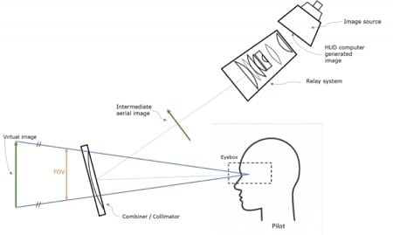

Figure 2.2: Basic imaging principle of HUDs (Aviation Today, 2022)

As the original meaning, HUD refers to display measurements where system user can obtain awareness of vital system state while maintaining observation of external environment. It is usually required that system states are highly integrated, meanwhile having minimalized visual occlusion to users’ view. Similar to HOTAS, this concept has been broadly applied to aviation, especially fighter jets. Pilots (or aviators) encounter facing complex battlefield environment, where fast judgement and reaction is essential. HUD devices were thus introduced to support the behavior. Fighter jet HUDs are typically integration of flight status, jet internal status, weapon and targeting status, navigation data, situation information, etc. Some HUD concepts were implemented on HMDs (head-mounted displays) where holographic projection are displayed on pilots’ helmet masks, forming a follow-up HUD graph despite stance of head.

A majority of HUD devices utilizes holographic imaging technology by projecting the desired information (usually caried by laser) on optical substances which are both reflective and transparent (typically on specifically crafted plain lens). The projected image features focal distance at infinity, forming an overlaid view where all HUD contents approximately align to distant objects. This nature appeals to aviation as pilots usually encounter looking at objects in distance, where the holographic graph can reduce the occasions that eyes adjust focal distance.

Practical HUDs tend to contain minimalized information, with typical instance displayed in figure 2.2. A majority of HUD elements are located away from but near the center, in order to reduce occlusion on the important central vision while providing convenience where pilots can easily read the contents using peripheral vision. In addition, the font of texts and figures appear to be similar to Open Sans, as compromise between readability and computational power (of processor in the aircraft’s HUD module). As both are also crucial to VR games, the designing 电视游戏的萤幕截图
appears to be adoptable to the development.

Figure 2.3: An instance of civil aviation HUD (Aviation Today, 2022)

It is also notable that aviation HUDs tend to adopt to a green theme color, while other bold colors (e.g. red, yellow) are only occasionally applied for warning effect by chromatic aberration. This is due to the importance that all HUD contents must be always bold to pilot eyes and never confused with the background (e.g. sky, ocean, vegetated surface). As justified by theories and verified by practices, the green theme color proved to form the minimalized visual confusion in general. Studies suggested that human eyes are most sensitive to green colors – at constant illumination, it is always easier to notice green color, and always easier to distinguish different green colors than any others. (“Three Concepts of Color,” 2015) In addition, an unnatural pure green (#00BF00) color was broadly applied for visual boldness. The methodology has not only been applied in reality but also been imitated by air combat games, such as Ace Combat and VTOL VR.

In summary to the research above, HUD in the game developed for research will adopt to following features:

* HUD should be rendered for binoculus stereo vision, with sufficiently long focal distances.
* HUD should provide visual feedback on vital information on player and game state.
* HUD should be monochromatic in general, while green is considered with priority.

## Equipment

Due to logical behavior of VR hand interaction, equipment in the game is divided to wrist equipment and firearms – the former is body-attached, irreplaceable equipment while the latter are pickup objects in nature. Operation of both types of weapons should adopt to the widespread convention of VR shooting games where:

* Weapons are picked up by pressing grip button on the interacting motion controller, and are dropped by releasing the same button. The grip button must be held to maintain control and orientation of the weapon.
* Fire action is performed via trigger on the motion controller (hand) which holds the weapon.
* Other actions, such as switch fire mode and releasing magazine) are mapped to other buttons on the hand (motion controller) holding the weapon.

While input set will be shared between wrist equipment and firearms, only one weapon may be activated on each hand. This issue should be resolved according to the state where player attempts to grab – in occasion where grip button is pressed on one motion controller, the following logic is processed with priority:

* firearm should be activated if any is picked up, otherwise:
  + wrist equipment should be activated if any is attached to the player hand, otherwise:
    - no action is performed.

HUD should also be implemented with display on state of activated equipment, as well as targeting information of it. Equipment state may consist of fire mode and remaining rounds, while targeting information may include floating crosshair and rangefinder. Two solutions originally designed by the proposer are supplied as below:

* Display state texts as follow-up HMD elements
* Display state as luminous texts on the surface of equipment

It is believed that both solutions can be implemented and utilized concurrently, in the form of either distinguishing between wrist equipment and firearms, or configurable according to players’ individual preferences.

It is intended that a secondary movement approach be implemented as grappling hook. Despite that no proper instances were found about real-life space grappling hook, sufficient inspirations could be made from existing games such as Call of Duty: Infinite Warfare (Activision, 2016). It is also believed that players can convert knowledge of grappling hooks from existing games and hence familiarize the system. Similar to the existing prototypes, grappling hook in the game under research should function in following sequence:

* Player should be able to easily activate grappling hook for quick reaction to game events
* Player should be able to target grappling hook voluntarily or semi-voluntarily, and fire at will.
* Grappling hook should pull player towards hit point once hitting any substance, and stop when player reaches destination.
* (additional) Grappling hook should provide functionality of hooking pickup objects towards player.

## Subsystems

A game menu is also required to configure equipment and game states. The choice of model is made between two types of game menus applied in a majority VR games: stationary menu and wrist menu. Stationary menu presents distantly in front of players in the form of a screen, often accompanied with game being paused. It is usually a static entity, not following of players’ VR orientations. Meanwhile, wrist menus are small, compact menus presenting at surrounding of player’s hands. It also features ‘soft activating’ where it may be presented on inputs different from button press – such as rotating motion controller to a certain orientation. In comparison, stationary menus are stronger visual indication due to the size, while a larger amount of content are supported also by the size. Meanwhile, wrist menus potentially form less occlusion to players’ view, and may increase ambiance and realism of the game (compared with stationary menu which has less realistic size and appearance).

Considering the fact that player view will be largely occupied by HUD, it is believed that stationary menu can cause significant visual occlusion. It is also determined in the proposal that high level of realism is required in the game. Thus, wrist menu is of choice by the proposer. In the game under research, the menu should present following features:

* Wrist menu should be presented with minimum number of actions. All menu items should also be minimalized in action and styles.
* Wrist menu should provide control access to both player equipment and game state.
* (additional) Wrist menu items should be dynamically changed in response to change of player state and game state.

# Methodology

## Tools and platforms

Due to the proposer’s technical experience and available project time, Unreal Engine 4.26.2 was selected as the primary development tool. The game engine features default visual scripting and physically based rendering (PBR) – the former is broadly utilized in game industry for improved scripting efficiency, while the latter may reduce specific working time on visual performance. The UE4 VR template was also adopted to reduce working time by partially utilizing the provided setup, such as scenes and object hierarchies. The development is also supported by softwares including Oculus and Oculus Developer Hub. The survey is supported by Google Forms, featuring sophisticated editable questionnaire, automatic result analysis and export. GitHub is adopted as source control tool – the project repository can be found at <https://github.com/kingwaykingway/Master-Project>.

Hardware resources utilized for development includes PC, Oculus Rift (Touch) and Oculus Quest. Several rooms and furniture are occupied to provide safe VR play zones for user test.

As the concentration of the project is HCI performance and gameplay, cross-platform support is not considered as essential task. Visual performance, program integrity and extensibility are considered as objectives secondary to core mechanism.

## Basic play information

The game developed in this project can only be run on PC connected with commodity VR set. For gameplay integrity, it is essential that any Oculus model be used, combined with dual motion controllers. For optimal runtime performance, the recommended hardware setup includes but is not limited to:

* GPU: GTX 1070 or higher equivalent
* RAM: 16GB or higher
* CPU:  Intel Core i7 or higher equivalent
* OS: Windows 10

The playing stance may be either standing or seated, while the latter is recommended. Players may apply any horizontal body orientation and rotate any time during play. Players may also move physically within safety capacity of VR guard zone (if configured properly).

For health concern, players with motion sickness should play with caution, and must quit playing as soon as possible when experiencing obvious dizziness. In addition, the game content may be harmful to players ever confirmed with (not limited to) following symptoms:

* Photosensitive epilepsy
* Acrophobia
* Claustrophobia
* Thalassophobia
* Megalophobia

Players with any diseases above should avoid playing the game for safety.

The game is free of following contents:

* Strong language
* Violence
* Sex indication
* Use of drugs, tobacco or alcohol
* Thrill or occult phenomenon

## Game flow

As a technical verification prototype, no complete game flows are presented in the game. There is no explicit guidance or goals directing players’ gaming conduct. During user test, players will be encouraged to first complete the tutorial, then explore existing mechanisms and objects in environment.

## Player hierarchy

The player character’s component hierarchy was inherited from UE4 VR template. The root component, as well as VR origin transform, represents the center of playzone. The camera attached to VR origin is mastered by VR head-mounted display, where player’s view is based. One pair of hands will be spawn at runtime and attached to VR origin, mastered by paired VR motion controllers. As is designed to imitate head stance, HUD is directly attached to camera to maintain relative transform with simplicity.

In addition to the legacy hierarchy from UE4 VR template, a scene component is attached to the VR origin. The node has position and yaw angle imitating the camera (i.e. HMD) while maintaining its relative pitch and roll. This particular design emphasizes player’s body position and orientation in reality, as reflected by the capsule collider attached to it.

## HUD

Inspired by realistic head-up displays, HUD in the game simulates intuitive, minimalized holographic projection on the astronaut mask. As a feedback segment of human-computer interaction, the HUD provides visualized essential information on system state, including motion state, equipment status, and spatial awareness (see figure 1.1).

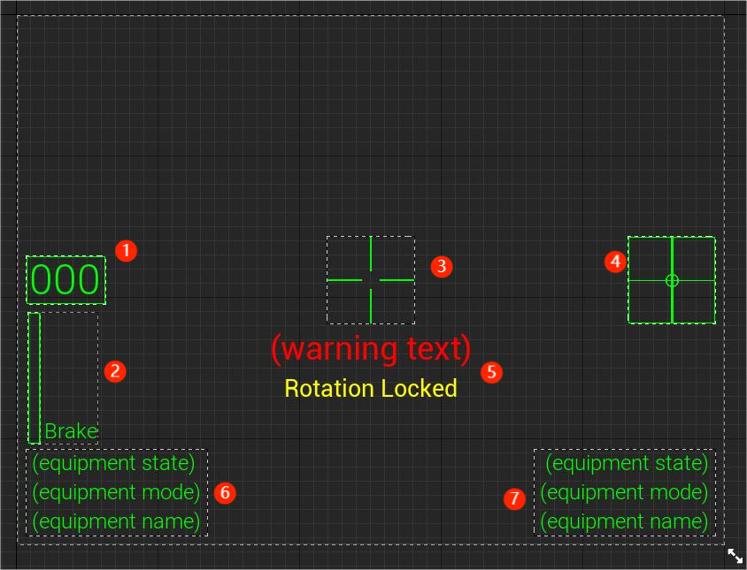

figure 3.1: HUD in widget design view.

Legend:

1. Speed indicator. Unit is meter per second.
2. Brake strength indicator. Only present when brake input is greater than 0. Progressive bar shows current brake input scale.
3. Fixed crosshair.
4. Rotation input indicator. Only active when rotation is unlocked.
5. Warning texts. Only visible when corresponding condition applies.
6. Left hand equipment info panel.
7. Right hand equipment info panel.

An attempted was made in early development stage to deliver HUD as conventional widget, a summary of Unreal Engine 2D entities. The outcome appeared to be complete failure in visual deliverance, as HUD elements were rendered at zero depth of field (referred as DoF below) on solely left VR goggle. With reference to multiple sources (“2D HUD Overlay in VR - Platform & Builds / XR Development,” 2017) (“How do I make my VR HUD Widget appear in front of everything else? : unrealengine,” n.d.), this phenomenon was explained due to following UE4 rendering logics:

1. Widgets in UE4 are always rendered at post-processing stage, implying they may never participate in 3D rendering.
2. The VR binoculus (double-eyed) displays were conventionally divided into 2 separate screens (one per VR lens), with screen UVs respectively mapped to U value of 0-1 on left screen and 1-2 on the right. (The similar behavior also applies to dual screen setup based on conventional displays.) The default post-processing material of widgets only renders to screen UV of 0-1, namely all contents are delivered on the leftmost display.

The principles above implies the incapability of 2D widgets on presenting HUD in VR mode. It is also suggested by these sources that all visual items must be rendered in 3D world to form focusable, stereo vision in head-mounted display.

The methodology was adopted in second attempt, where all HUD elements are projected on 3D surfaces with constant focal distance of approximately 60 meters, rendered occluding other world entities. This particular method, inspired by the game VTOL VR (Boundless Dynamics, 2017), eventually reached proposer’s expectation.

The rendering logics above were also flexibly utilized for presenting monocular (single-eyed) vision, inspired by early Apache Attack Helicopter’s monocular eyepiece (Keller, 2014). Phasmophobia, a VR thrill game, is also known for utilizing the mechanism for strengthening thrilling atmosphere (“Kinetic Games,” n.d.). As a potential extension to human-computer interaction, players may choose to keep a single eye open to switch between HUD overlaid view and HUD-free view accordingly. Nonetheless, it is a notable fact that monocular displays are being gradually replaced by binoculus ones in military utility, as they are noticed for causing discomfort in binocular vision (“US Army carried out flight tests with new HMD for AH-64E Apache helicopter,” n.d.).

电脑游戏画面

Figure 3.2: UE4 material (shader) graph for VR monoculus visual effect.

Implementation of monoculus visibility is as displayed in figure 3.2. The UE4 material graph functions as integration of multiple shaders including pixel shader. In this graph, screen UVs are read per pixel, mathematically processed such that the screen UV per pixel is compared with 1. Pixel opacities are then distinguished by the result to either 1 or 0, resulting in the same object being visible in one display while not in another. Scalar parameter named ‘eye mode index’ is introduced with purpose that the behavior is configurable. The value of 0 implies visible to both eyes, 1 for left eye only and -1 for right eye only. Several other parameters are also introduced for more flexible behaviors which are exclusively implementable in material graph, such as emission brightness. The configurations are adopted as material domain of surface, blend mode of additive and shading model of unlit. With attempts made, it is believed that this is the unique setting where HUD is properly displayed with transparent background. The resultant visual effect has recreated all key features of real-life aviation HUDs, as is tested and judged by the proposer.

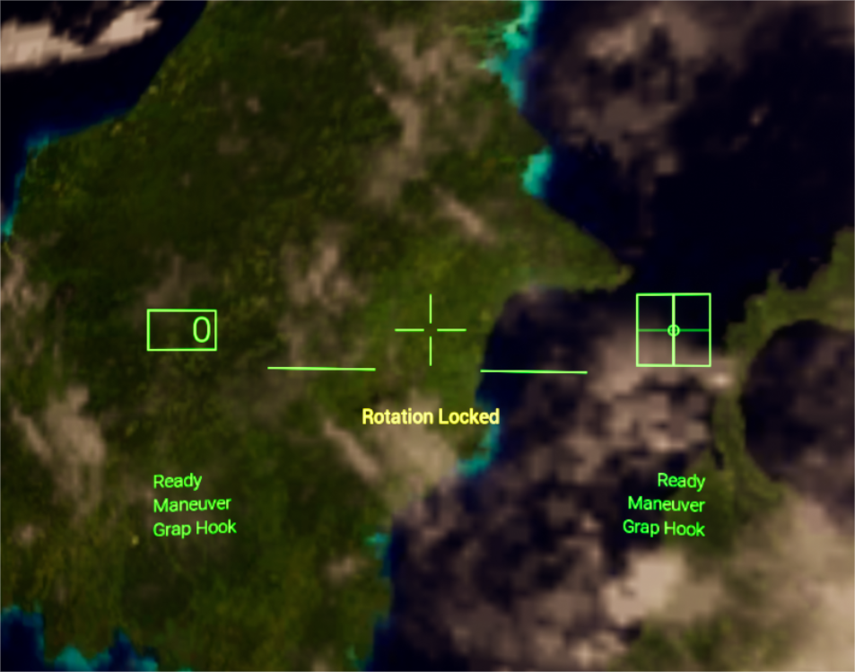

Figure 3.3: HUD rendered in game.

(The screen capture is solely from HDM left eye and does not represent final effect in VR view.)

The HUD system also includes individual tracking marks attached to player character. As contribution to player’s spatial awareness, these marks were designed for marking orientations of any object or transform from player’s view. Possible objects include predicted hit point, interactive objects, mission objectives (see figure 1.3 below).

Figure 3.4: HUD with a track mark.

The green square with text ‘Locked’ marks an interactive power cell in the scene.

It is locked by the right hand grappling hook on ‘grab’ mode.

To integrate into HUD, location and rotation of all tracking marks are recalculated at real time (as displayed in figure 3.5), maintaining their focal distance on the extension line between player viewport and the tracked object. As the result, the marks remain facing player, meanwhile imitating player’s tilting (i.e. roll) of HMD – this is helpful when texts are embedded in HUD system, since the texts must be maintained horizontal to player’s view for optimal readability.

Figure 3.5: UE4 blueprint function which calculates transform of HUD track marks.

As a backup method of preventing HUD vision blockage, two virtual buttons were placed at forehead position of HMDs. Players can find the buttons by reaching their hands to front sides of HMDs, then pressing trigger, to quickly toggle HUD visibility.

## Jetpack

Jetpack is designed as primary approach player moves as an astronaut in the game. Similar to real-life astronaut jetpacks, it provides 6 degree-of-freedom translational and rotation control by applying respectively linear and angular momentum to astronaut. In this game, differences are made where all controlling of the jetpack are assembled at a flight control stick located front left of player’s waist. This interaction model is supported by input set of Oculus motion controller, where sufficient inputs enabled rotation by rotating control stick, as well as locomotion using thumbsticks and buttons. The simplified interaction model also enabled one spare hand for complex tasks in the game.

Figure 3.6: UE4 blueprint function which converts motion controller rotation to character movement input.

Rotation control is simulated by rotation of motion controller, with controlling logic similar to real-life aircraft control sticks. Yaw, pitch and roll are mapped to corresponding rotation actions. At the start of game, rotation is locked to prevent accidental operation causing dizziness.

|  |  |
| --- | --- |
| Input | Action |
| Thumbstick Y | Move forward/backward |
| Thumbstick X | Move right/left |
| Y/B | Ascend |
| X/A | Descend |
| Trigger (axial) | Brake |
| Thumbstick press | Toggle rotation lock |
| Rotate around X axis | Pitch |
| Rotate around Y axis | Yaw |
| Rotate around Z axis | Roll |

Table 3.1: Input set while motion controller is holding flight control stick.

## Grappling Hook

Grappling hook is intended as secondary approach that player maneuvers in environment. It performs function by pulling player towards hit objects. At later development stage, the functionality was expanded to locking on specific object and pulling it towards player. Both functionalities are separated by firing mode of ‘maneuver’ and ‘grab’. When grappling hook is activated, player can easily switch fire mode by pressing buttons on motion controller.

|  |  |
| --- | --- |
| Input | Action |
| Trigger | Fire |
| Y/B | Switch fire mode |

Table 3.2: Input set while grappling hook is armed on one hand.

Logic structure of grappling hook launcher is generally inspired by state machine. As displayer in figure 3.7, one main state is switched at real time among five states: idle, targeting (hit), targeting (missing), launched, pulling. Nevertheless, as sophisticated behaviors are implemented in grappling hook, additional variables were introduced to completely maintain the object state. Operations are selectively executed as summary to various states. For instance, a tracking mark is instantiated when the grappling hook is armed, settled in position when the projectile hits a target, and destroyed when pulling is completed.

Figure 3.7: Tick function in grappling hook blueprint.

Grappling hook projectiles is attached with UE4 in-built projectile movement component, which automatically manages movement of the object. As is designed, grappling hook performs different actions according to object type hit by the projectile. If an object is effectively a ‘pickup’ object, it will be pulled towards player. Otherwise, the projectile remains at hit point, and player will instead be pulled towards it.

Figure 3.8: Grappling hook’s targeting system while activated.

The circle-dot mark at bottom of image indicates hit point, while the text shows distance between grappling hook and the expected hit point.

## Wrist menu

Wrist menu acts as an integration of in-game configurations and commands. Similar to HUD, a green theme color was adopted in the menu, with transparent green background to prevent visual interruption.

In the final build, wrist menu consists of following functionalities:

* HUD switch (as backup to helmet HUD switch)
* HUD eye mode
* HUD brightness
* Auto brake (not implemented)
* Reset player location
* Play tutorial
* Restart level
* Quit game

Through this compact menu, players are able to configure their equipment, as well as controlling the game state. The menu can be operated by pointing player’s other hand (where wrist menu is not activated) onto the menu. A green beam will present, with whose end functioning as cursor. Players may then move the beam such that it hits interactive menu elements (e.g. buttons), then press trigger to activate them.

In addition, the wrist menu is implemented with potential extensibility. A series of widget blueprints are implemented as class templates. Several functionalities were intended but not implement for the limit of project time, such as configuration on jetpack rotation sensitivity.

## Tutorial

In addition to core gameplay, a tutorial is set to instruct players with basic operations. The tutorial consists of a linear sequence of text guidance, each of which suggests player with one feature of core mechanism. The hints were delivered in following order:

* HUD
* Wrist menu
* Jetpack
* Grappling hook (maneuvering mode)
* Grappling hook (grabbing mode)

Due to limitation of project time, the sequence only proceeds under simple conditions. For instance, the hint on HUD disappears immediately when HUD is switched on, while the hint on grappling hook disappears when grappling hook is activated. It is intended that more sophisticated behaviours be introduced in case players fail to tightly follow the tutorial.

## Level design

As complementary to the game mechanism and narrative, a zero-gravity space level is created for demo and user test. The level is placed with following objects.

* Space station as the sole terrain mesh.
* Interactive objects: blue cubes and power cells.
* Dummy celestial bodies – sun and earth, as background.
* Space skybox.
* Post-processing volumes.

As the sole level presented to players and user test participants, the level simulates fictional astronomy in earth orbit.

# Evaluation

## Self-analysis

By the end of development stage, a playable, bug-free game had been implemented with sufficient focus on core mechanisms. In spite, there was comparative lack of polishing. Before conducting user test, the proposer had noticed several issues.

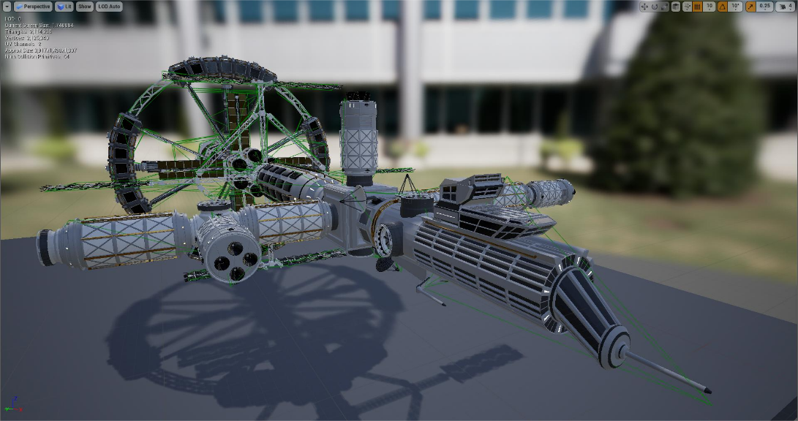One issue found by the proposer was that collision of the space station did not match geometry of the model. The issue boiled down to the fact that the space station model was outsourced and was not specifically created for Unreal Engine. The model could only be imported as one entire mesh with approximately 48 material channels and massive number of geometries. In UE4, while complex collision has geometry equivalent to mesh geometry, simple collision must be generated using engine in-built algorithm and frequently implies reduced number of geometries. Meanwhile, usage of simple collision was enforced in most physical events. Consequently, the actual collision geometry was not aligned to edges and faces of the visible model (see figure 4.1).

Figure 4.1: UE4 static mesh viewer of space station

Another issue was observed when interacting with wrist menu while one ‘hand (slaved to one motion controller)’ was overlapping an environmental pickup object. The concrete cause remains undiscovered but was believed by the proposer due to the legacy object hierarchies. To preserve program integrity, decision was made where the prepared object hierarchies in project template would not be removed. Those hierarchies consist of numerous components, many of which participates in collisions. It is believed that the complex collision state could cause mistaken judgement made by widget interaction components.

The last issue was physical glitch when a pickup object was at pulling trajectory termination of grappling hook. Occasionally, the objects would vibrate irregularly in space for several frames when pulling was finished, despite that the object position was usually restored afterwards. The vibration is known to experienced developers as physical repel, caused by misplacing overlap between two rigid physical objects. Any dynamic physical objects would be applied with a radial force depending on the physical property of both objects as well as the overlapping status. In context of grappling hook in this game, pulling was finalized with a sole condition where the projectile’s proximity trigger overlaps with player body. Velocity of the pickup object will then be zeroed within the frame to prevent collision. This implementation could effectively prevent pulled object from bouncing away due to collision with player’s physical body, whereas it is also important to keep the objects within players’ hand reach. Nonetheless, inaccuracy may be present at the frame overlap event is triggered, as a vast majority of decimal data in UE4 was in float format, featuring less demand on CPU and memory, as well as lower precision. The possible situation may occur that, at the frame overlap event was triggered, the actual position of the pickup was further along the trajectory inside the overlapped player body. The physics engine then attempts to adjust position, with frequent success. Attempts has been made by the proposer to improve physical behaviour in script level with minor improvement. However, physics system of the game engine is expected to be modified, provided that physical performance were focus of the project.

For the lack of available time for the project, significant amount of scope in the project was denied for implementation, including several details that may potentially improve HCI performance.

## User test designing

As HCI performance and gameplay are emphasized in the research, user test and survey will concentrate on these aspects of the developed game.

User test will be conducted by individuals excluding the proposer, the project supervisors or any other persons with insight of the project. In-depth information of the project will remain secret to each participant before user test.

User tests were conducted under guideline of scientific research ethics. All usage of material and field were under consent and permission of owners. Personal information of participants was collected with limit and were kept confidential. For health and safety concern, participants will be provided with consent of potential risk before playtesting and may stop playtesting any time without having to provide reason.

For on-site participants, testing field and materials were properly set by the proposer. The proposer attended all on-site tests providing supervision, observation, protection, and technical support. Meanwhile, the proposer produced minimalized interception during the user test to reduce interruption to results. For remote participants, field and materials were prepared by the participants. Naturally, it is responsibility of the participants to ensure safety during the tests.

The user test consists of 3 major sections: pre-test survey, playtesting, post-test survey. The length guideline of user test is approximately 30 minutes, where a minimum of 10 minutes should be allocated on playtesting. As several participants were only able to conduct remote user test, it is essential to assume absence of support by the proposer. Thus, timing is not enforced for all participants.

Evaluation in this project will be based on user test participants’ feedback to the questionnaire, where analysis will focus on following aspects:

1. Compare between each participant’s background and play test experience, hence determine difficulty of handling the game for various player groups.
2. Based on SUS (System Usability Scale), convert participants’ play test experience from qualitative data to quantitative ones, hence deriving statistics as measure of HCI performance.
3. Based on participants’ feedback on gameplay popularity, criticize the potential of the originally designed gameplay.

## Survey questionnaire

As deployed in 4.1, survey is divided to two sections. Pre-test survey mainly focuses on participants’ background of gaming and knowledge of real-life prototype of subsystems in the game under test. It is important that the questionnaire be filled before playtesting, as participants may potentially develop knowledge on some systems during playtesting, hence providing inaccurate feedback on their background. On the contrary, all questions in the post-test questionnaire is tightly correlative to the game contents, thus should only be completed after playtesting.

To support remote user test, Google Forms is utilized to create online questionnaire. All participants were given the web link during user test. <https://docs.google.com/forms/d/e/1FAIpQLSfeAfOlAkXc_Pb0ZQ4zC941ofpFMSipUUEgLAdIyLx72p5oog/viewform?usp=sf_link>

As displayed in figure 4.1, the first three questions are about participants’ generic background on gaming. Question 1 classifies participants’ familiarity with commodity VR devices, rating from experienced to rarely used. An additional option were added as a) for Oculus model, as the game under research is Oculus standalone. Experience on Oculus model will be treated as additional background knowledge. Question 2 studies about participants’ overall gaming experience, hence help classifying each participant to certain player group. Question 3 reflects participants familiarity of all game genres related to the game under research.

Figure 4.2: Pre-test survey question 1-3

1. **Choose 1 option below that fits you best.** 
   1. I have experience using an Oculus model VR device.
   2. I have used commodity VR devices other than Oculus (HTC Vive, Valve Index, PSVR, etc).
   3. I have experienced 3D vision products (e.g. 3D movies, mobile VR) but not using interacive VR techniques.
   4. I had limited exposure to 3D vision techniques.
2. **Select all options below that applies to you.** 
   1. I have experienced more than 30 games in total.
   2. I have spent significant time (>200 hours) on a single game.
   3. I have / ever had (and have used) hardware/devices specifically for gaming (gaming GPU, gaming consoles, game controller, dance mat, etc.).
3. **Which of the following game genres/tags/elements have you ever experienced? Select all that applies to you.** 
   1. Shooting
   2. First-person perspective (including VR)
   3. Puzzle
   4. Space
   5. Science fiction
   6. Flying / air combat
   7. Story-based
   8. Sandbox

Figure 4.3: Pre-test survey question 4-6

1. **Choose 1 option below that fits you best.** 
   1. I have experience using real-life flight control devices (for piloting real aircrafts / as gaming HOTAS device).
   2. I know basic mechanisms of flight control, but haven’t interacted with real-life models.
   3. I have very limited knowledge on flight control.
2. **Select all options below that applies to you.** 
   1. I have basic knowledge of optics.
   2. I have been exposed to following real-life optical devices: red dot sights, holographic projectors, head-up displays.
   3. I have seen realistic HUDs in games and developed basic understanding of them.
3. **Select all options below that applies to you.** 
   1. I have basic knowledge of kinetics.
   2. I understand the difference between earth environment and space.
   3. I am interested in, or have been exposed to astronomy (e.g. visited relevant things in museums or amusement parks).
   4. Except for games, I have read or watched sci-fi art pieces (e.g. novels, documentaries, movies).

Questions 4-6 focus on participants’ knowledge of certain real-life principle or phenomena. The user test experience of each participant will be compared to his/her feedback on those questions. Question 4 is specifically relative to the jetpack subsystem, where participants’ knowledge on flight control is important for mastering this game system. Question 5 is relevant to knowledge of knowledge on aviation HUD which is expected to aid participants with understanding HUD in the game. Question 5 is about the generic science fiction theme, including knowledge of physics. It is expected that the knowledge will help participants develop understanding of the game scene, psychologically overcome discomfort of space environment, as well as understanding the in-game fact that player tend to maintain its movement state due to inertia.

However, no questions were set regarding grappling hook. This is due to the fact that grappling hook is utilized in massive limitation in reality, and is not known of usage in astronomy. Thus, grappling hook in the game is technically a science fictional concept, and players cannot handle the system based on any knowledge of reality.

Figure 4.4: Post-test survey question 1

1. **Rate from 1 to 5 for the extent to which you agree with following comments of the game in general.**

*5 - Strongly Agree*

*4 - Agree*

*3 - Neutral*

*2 - Disagree*

*1 - Strongly Disagree*

* 1. I think that I would like to play this game frequently.
  2. I found the game unnecessarily complex.
  3. I thought the game was easy to play.
  4. I think that I would need the support of a technical person to be able to play this game.
  5. I found the various functions in this game were well integrated.
  6. I thought there was too much inconsistency in this game.
  7. I would imagine that most people would learn to play this game very quickly.
  8. I found the game very cumbersome to play.
  9. I felt very confident playing the game.
  10. I needed to learn a lot of things before I could get going with this game.

This question is directed by theory and methodology of SUS (System Usability Scale). It provides general measure of usability of all systems in the game. A summary of 10 questions were provided to convert qualitative comment to quantities. Basic statistic methods would then be introduced to show a general SUS figure.

Figure 4.5: Post-test survey question 2-5

1. **Select all options below that applies to you.** 
   1. I understand what astronaut jetpack is, and how it works, in this game.
   2. By the end of playtesting, I felt I have good control over jetpack.
   3. I felt visually comfortable (i.e. not dizzy) while maneuvering using jetpack.
   4. I found jetpack a good restoration of real-life equivalent or fiction.
2. **Select all options below that applies to you.**
3. I understand what grappling hook refers to, and how it works, in this game.
4. I found grappling hook helpful with maneuvering.
5. I found grappling hook useful when trying to pick up items.
6. I felt visually comfortable (i.e. not dizzy) while maneuvering using grappling hook.
7. I found grappling hook a good restoration of real-life equivalent or fiction.
8. **Select all options below that applies to you.**
9. I understand what HUD refers to, and what it does, in this game.
10. I found HUD comfortable to look at (e.g. not any prickly to eyes, not blocking normal vision, not adding to dizziness, not affecting eye focus).
11. I found HUD contents easy to understand (i.e. they are self-explanatory).
12. I found all information delivered by HUD important/useful.
13. I am satisfied with all HUD elements properly stylized (e.g. Text font sizes are neither too large that blocks normal vision, nor too small to read.)
14. I found HUD a good restoration of real-life equivalent or fiction.
15. **Select all options below that applies to you.**
16. I understand what wrist menu is, and what it does, in this game.
17. I found wrist menu easy to operate.
18. I received clear feedback interacting with wrist menu.
19. I found all functionalities assembled in wrist menu necessary.

Each question above focuses on one subsystem designed and implement in the game under research.

Figure 4.6: Post-test survey question 6-9

1. **Which approach would you prefer to use for moving yourself in this game, jetpack or grappling hook? Choose 1 option below.**
2. Jetpack.
3. Grappling hook.
4. I like both equally.
5. **If further updates are published, are you willing to continue experiencing the game?**
6. **Will you recommend the game to friends/acquaintances?**
7. **Are there any additional comments you would like to make? (open question)**

## Survey results and analysis

A summary of 11 participants conducted the user test with feedback provided. Original copy of questionnaire responses are stored in Google Forms, with access link at: <https://docs.google.com/forms/d/1JdK5N7dqVaB5nGSnL-_LRPqjbL5uiMzRhmb3tp6riyc/edit#responses>.

As displayed in Figure 4.6, it is evident that over half of the participants (6 persons) have had sufficient experience before playtesting, in respect to platform support limitation of the game. Meanwhile, a significant number of the participants (4 persons) had very limited exposure to VR games in general, thus were predicted to face challenge during playtesting.

Figure 4.7: Response to pre-test survey question 1

Despite the limitation of devices as in figure 3.1, all user test participants may be classified as experienced players. The bias of user group will be considered

Figure 4.8: Response to pre-test survey question 2

It is observable that most game genres had been experienced by a majority of participants, with exceptions on ‘puzzle’ and ‘air combat’. This is believed to have significant effect on gaming experience, as players with insufficient knowledge on aviation are expected to encounter confusion when using with flight control stick, while player with less experience on puzzle solving game tend to miss more details in game.

Figure 4.9: Response to pre-test survey question 3

It is evident that a vast majority of participants have limited knowledge of flight control models. This is believed to affect gaming experience and increase difficulty of handling the jetpack controller.

Figure 4.10: Response to pre-test survey question 4

Responses to this question showed a similar trend as others: basic theories are frequently popularized, while real-life models (or prototypes) tend to be the least experienced form. Simulator games appear to form the ‘bridge’ in between, providing simulation on objects inaccessible by players.

Figure 4.11: Response to pre-test survey question 5

Responses to question 6 reflected the widespread knowledge of science and science-fiction genre. Thus, little comparison can be made in this project between knowledge on science and gaming experience.

Figure 4.12: Response to pre-test survey question 6

Responses to the SUS question is as displayed in figure 4.12. In general, responses to most questions showed the trend of being neutral (i.e. between ‘agree’ and ‘disagree’). As displayed in table 4.1, the data was exported to excel forms and converted to numeric figures according to SUS guideline.

Figure 4.13: Response to post-test survey question 1 (SUS)

|  |  |  |  |  |  |  |  |  |  |  |  |
| --- | --- | --- | --- | --- | --- | --- | --- | --- | --- | --- | --- |
|  | Q1 | Q2 | Q3 | Q4 | Q5 | Q6 | Q7 | Q8 | Q9 | Q10 | SUS |
| #1 | 1 | 3 | 1 | 1 | 2 | 3 | 1 | 2 | 1 | 2 | 42.5 |
| #2 | 2 | 1 | 1 | 3 | 3 | 3 | 2 | 2 | 1 | 3 | 52.5 |
| #3 | 3 | 3 | 2 | 3 | 4 | 3 | 1 | 3 | 2 | 2 | 65 |
| #4 | 2 | 2 | 2 | 3 | 4 | 4 | 3 | 4 | 1 | 2 | 67.5 |
| #5 | 3 | 3 | 1 | 3 | 4 | 4 | 1 | 3 | 1 | 1 | 60 |
| #6 | 2 | 3 | 3 | 4 | 4 | 3 | 1 | 4 | 4 | 3 | 77.5 |
| #7 | 4 | 2 | 3 | 2 | 4 | 3 | 1 | 3 | 2 | 2 | 65 |
| #8 | 2 | 3 | 2 | 4 | 2 | 3 | 3 | 2 | 3 | 3 | 67.5 |
| #9 | 3 | 3 | 2 | 3 | 3 | 3 | 1 | 2 | 3 | 3 | 65 |
| #10 | 3 | 3 | 3 | 3 | 3 | 3 | 2 | 3 | 1 | 3 | 67.5 |
| #11 | 3 | 2 | 3 | 0 | 3 | 4 | 1 | 4 | 1 | 1 | 55 |

Table 4.1: Converted SUS responses of all participants. Each column represents one question, while each row represents one participant’s responses to the questions. The last column contains the derived SUS figure.

The SUS score has mean value of ~62.28 and median of 65. This implies that a certain degree of usability is achieved in an objective standard.

In comparison between individual participant’s SUS score and responses to other questions, a regular pattern is found where participants who have more knowledge of games or real-life prototypes usually provided more optimistic feedback on gaming experience. Despite that the proposer’s hypothesis between certain knowledge and gaming experience has been justified by the results, it is also essential that the game provides accessible approaches where players with limited professional knowledge can also master the gameplay.

According to Figure 4.13, a majority of participants appeared satisfactory to three features of jetpack movement and control. The only exception is found on visual dizziness. As observed by the proposer during each playtest, participants unfamiliar to VR tends to feel visual discomfort more frequently during rotation actions. Several participants also clearly stated on the discomfort from disorientation despite continuing the tests. It is believed that such HCI model containing rotation operations need to be designed and implemented with further improvement, hence maintaining visual comfort and preventing motion sickness. Potential measurements may include:

Figure 4.14: Response to post-test survey question 2

* Reducing rotation sensitivity
* Applying post-processing effects, such as motion blur

Similar to post-test survey question 2, feedbacks were generally positive on options except for visual comfort and core usability. Feedbacks which were relatively negative on option 2 is accountable – based on the proposer’s observation during play test, there were insufficient surfaces in the scene where grappling hook can absorb, while the firing range of grappling hook were preserved at default value of 50 metres. Consequently, most grappling hook shots were missing, preventing participants from maneuvering voluntarily.

Figure 4.15: Response to post-test survey question 3

The feedback received is positive in general. With reference to the post-test question 9, negative answers to option 3 and 4 appeared due to insufficient gameplay complexity which justifies necessity of a sophisticated HUD. Those to question 2 and 5 may boil down to object scale and font settings. In comparison with feedback on pre-survey question 5, it is believable that lack for knowledge of real-life HUD may lead to several negative feedback on question 6. The rest appear to derive from originality of HUD designing in this game, where a significant amount of elements were absent compared with real-life HUDs.

Figure 4.16: Response to post-test survey question 4

The feedback received is positive in general. As is observed during development, the minor negative responses are believed to be caused by the hand collision issue reflected in 4.1.

Figure 4.17: Response to post-test survey question 5

Despite the positive comment on grappling hook received in post-test question 9, a majority of participants showed preference on jetpack over grappling hook. The trend conforms the intention that jetpack would be the primary movement method. Meanwhile, jetpack proves more successful as implementation, since approximately equal amount of effort was made on both systems.

Figure 4.18: Response to post-test survey question 6

Responses to question 7 indicated a good expectation of future potential of the game framework. As large amount of designing was not implemented due to limited project time, the designing is expected to have good compatibility yet important effect to gameplay and HCI performance.

Figure 4.19: Response to post-test survey question 7

Figure 4.20: Response to post-test survey question 8

The responses indicated a good gameplay popularity in general, despite the aviation and astronomy as niche elements.

As displayed in figure 4.20, several issues were explicitly pointed out in the open question, including:

Figure 4.21: Response to post-test survey question 9.

Several participants did not provide response as the question is optional.

* The subtitles of the hint of the tutorials run too fast, and sometimes are hard to follow, I made some mis clicks during the game and skipped some of the tutorials. The tutorial hint sometimes makes me feel confused about what to do next. During the gameplay, my character was stuck in other models, it would be great if there are some hints to tell the player can move to original space with the reset position function. The high-speed jetpack makes me feel a bit dizzy, it can be adjusted. How to aim and use the hook is a bit complicated for me, and I didn't manage to totally figure it out during experiencing. Without background knowledge, I am a bit confused about what HUD is and what I'm supposed to do with it.
* Sound feedback could aid the player - letting them know when they have successfully completed a tutorial task or performed a function/used an item/jetpack.
* overall game environment was very interesting, and the jet pack movement, grappling hook and surroundings created excellent emersion. The instructions were very clear, although some aspects of the gameplay may be difficult for those who have never used a VR console previously.
* The game was a super fun VR experience to have. As a person who loves to see the VR games taking their route towards the development, it's great to have people come up with such ideas and implementing them into working games that players can experience with it actually being so surreal and immersive. The models used were super good and I felt like a part of me was on a real space station for a moment. Would love to see more features being added to the game and hope to pick it up on the market. Thanks!
* The game is original, which is hard to come by. The only issues I've experianced is that the collions with entity's and the level, the entity would go though the level instead of properly colliding with it. The grappling hook also could you with a release mechanic for smoother movment.
* HUD was jarring and overlapped with other information, making it hard to read without having to turn my head away to an empty space. Would like to keep my Crosshair when disabling HUD, makes shooting grappling hook confusing. rotating was difficult.
* It's a brand new experience for me and was extremely positive. I would love to revisit the simulation at further stages of the game.
* The text based instructions were quite good but for novice players some more visual guidelines either by format of navigation style inputs like the ones in say borderland or such would greatly help with the learning curve associated with understanding the controls more.
* Improper occlusion and timing of the tutorial subtitle
* Intersection between HUD and tutorial subtitle
* Consolidated switch of all HUD elements (including track marks)
* Inconvenience caused by semi-follow-up jetpack controller
* Lack of interaction in grappling hook, where player should be able to perform firing and pulling action separately
* Lack of details, pace too fast in tutorial
* Complete absence of sound
* Gameplay hard to handle for beginners

The responses provided valuable reference for improvement beyond as covered in the questionnaire. Meanwhile, the responses provided positive comments on originality of the game.

# Conclusion

At the end of the study, a functional, stable, integral game is implemented. Feedback from user tests indicated a positive comment in general, while potential improvement is also explicitly suggested. Based on analysis of user test, research questions are answered as following:

1. The HCI performance has been quantified as SUS. The average SUS score received for the game under research is 63.28, suggesting a playability which is relatively positive. A majority of qualitative assessment criteria also received positive feedback from over 60% of user test participants.
2. With comparison between background knowledge and gaming experience, it is evident that there is strong, positive correlation between user knowledge of real-life prototypes and their imitations in the game.
3. Several originally designed gameplay systems have received positive feedback, including HOTAS jetpack, space grappling hook, astronomy-purposed HUD, as well as monocular visibility of object.

Beyond the framework of research, user test participants have also suggested additional gameplay elements which may enrich the game content.

Should more time be permitted, a large number of subsystems would be implemented, Improvements would also be applied to the existing gameplay elements. Should the study be re-conducted, the development process would be scheduled in a similar structure and length, as time has been utilized at good efficiency. However, several attempts with failure could be avoided.

# References

1. 2D HUD Overlay in VR - Platform & Builds / XR Development [WWW Document], 2017. . Unreal Engine Forums. URL <https://forums.unrealengine.com/t/2d-hud-overlay-in-vr/100837> (accessed 9.19.22).
2. Affairs, A.S. for P., 2013. System Usability Scale (SUS) [WWW Document]. URL <https://www.usability.gov/how-to-and-tools/methods/system-usability-scale.html> (accessed 9.20.22).
3. Boundless Dynamics [WWW Document], n.d. . Boundless Dynamics. URL <https://vtolvr.bdynamicsstudio.com/> (accessed 9.20.22).
4. Call of Duty®: Infinite Warfare [WWW Document], n.d. . Call of Duty®: Infinite Warfare. URL <https://www.callofduty.com/infinitewarfare/uk/en/infinitewarfare> (accessed 9.20.22).
5. Cooking Simulator on Steam [WWW Document], n.d. URL <https://store.steampowered.com/app/641320/Cooking_Simulator/> (accessed 9.20.22).
6. End Space - Welcome to the Tartarus Sector [WWW Document], n.d. . End Space. URL <http://endspacevr.com/> (accessed 9.20.22).
7. Grappling Hook - Download Free 3D model by Leafdroid, n.d.
8. Hot Dogs, Horseshoes & Hand Grenades [WWW Document], n.d. URL <http://h3vr.com/> (accessed 9.20.22).
9. How do I make my VR HUD Widget appear in front of everything else? : unrealengine [WWW Document], n.d. URL <https://www.reddit.com/r/unrealengine/comments/93xjie/how_do_i_make_my_vr_hud_widget_appear_in_front_of/> (accessed 9.20.22).
10. I Expect You To Die | I Expect You To Die | Schell Games [WWW Document], n.d. URL <https://iexpectyoutodie.schellgames.com/> (accessed 9.20.22).
11. Job Simulator: the 2050 Archives | Owlchemy Labs [WWW Document], n.d. URL <https://jobsimulatorgame.com/> (accessed 9.20.22).
12. Keller, J., 2014. Elbit to provide spare circuit cards for Apache helicopter helmet-mounted targeting system [WWW Document]. Military Aerospace. URL <https://www.militaryaerospace.com/defense-executive/article/16718595/elbit-to-provide-spare-circuit-cards-for-apache-helicopter-helmetmounted-targeting-system> (accessed 9.20.22).
13. Kinetic Games [WWW Document], n.d. URL <https://kineticgames.co.uk/> (accessed 9.20.22).
14. Lone Echo, n.d. URL <https://www.echo.games/> (accessed 9.20.22).
15. MiG-23MLD Flight Stick - Download Free 3D model by æck (@aeck2142), n.d.
16. More Favored than the Birds The Manned Maneuvering Unit in Space [WWW Document], n.d. URL <https://history.nasa.gov/SP-4219/Chapter13.html> (accessed 9.20.22).
17. Oculus Developer Hub: Unity | Oculus Developers [WWW Document], n.d. URL <https://developer.oculus.com/documentation/unity/ts-odh/> (accessed 9.19.22).
18. Oculus Quest Store: VR Games, Apps and More [WWW Document], n.d. . Oculus. URL <https://www.oculus.com/experiences/quest/> (accessed 9.20.22).
19. Quality Considerations for Aviation Head-up Displays (HUDs) [WWW Document], n.d. . Radiant Vision Systems. URL <https://www.radiantvisionsystems.com/blog/quality-considerations-aviation-head-displays-huds> (accessed 9.20.22).
20. Realistic 3D Earth Model With 4K Textures - Download Free 3D model by Omer Bhatti (@OmerBhatti), n.d.
21. Sci-Fi Space Station - Download Free 3D model by Helindu, n.d.
22. The Climb | VR, Video Games | Crytek [WWW Document], n.d. URL <https://www.theclimbgame.com/> (accessed 9.20.22).
23. Three Concepts of Color: A Philosopher’s Journey Part 2, 2015. . Munsell Color System; Color Matching from Munsell Color Company. URL <https://munsell.com/color-blog/concepts-philosophy-of-color-part2/> (accessed 9.20.22).
24. US Army carried out flight tests with new HMD for AH-64E Apache helicopter [WWW Document], n.d. URL <https://www.airrecognition.com/index.php/news/defense-aviation-news/2021/september/7601-us-army-carried-out-flight-tests-with-new-hmd-for-ah-64e-apache-helicopter.html> (accessed 9.20.22).
25. VR, O., n.d. Oculus Developer Hub 2.0 [WWW Document]. URL <https://developer.oculus.com/blog/oculus-developer-hub-20/URL> (accessed 9.20.22).
26. Wandering in space on Steam [WWW Document], n.d. URL <https://store.steampowered.com/app/1971770/Wandering_in_space/> (accessed 9.20.22).